WESTAR Council

Air Quality
Dispersion Modeling

September 10-11, 2024

State of New Mexico – Dept of Health
Runnells Building
1190 St. Francis Drive
Santa Fe, NM 87124

REGISTRATION DEADLINE:
Friday, August 9, 2024

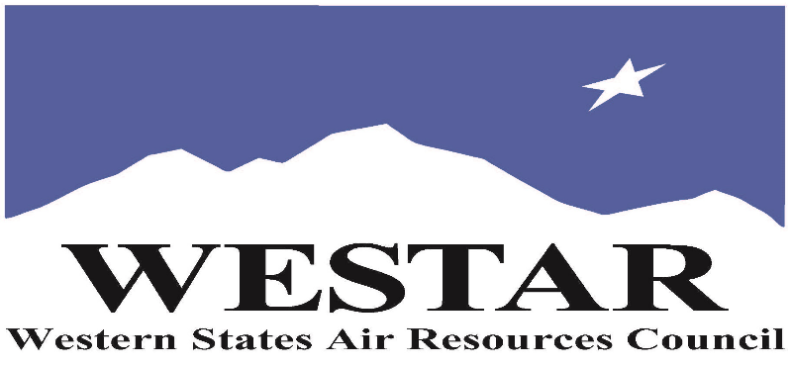

TO REGISTER
- Log onto EPA’s AirKnowledge and create a profile, or log onto your existing AirKnowledge account.
https://epaapti.csod.com/client/epaapti/default.aspx
- When you complete your profile, you will receive a confirmation e-mail to activate your new account. It may take several minutes before receiving the email.
- Once activated, log into your account.
- Click the “Instructor Lead Training Calendar” link under the “My Training” tab.
- Search the calendar for the training date(s). On the calendar you will see a course description. Hover over the text for additional information.
- To register click the course title link.
- In the lower righthand corner of the page you will see a “Request” button. Click it.
- At this point you have requested a seat in the training. Because demand for WESTAR sponsored training frequently exceeds availability all registrants are placed on a waitlist.
- You will receive an email from Jeff Gabler confirming your request.
- WESTAR attempts to accommodate all requests but at times it may be necessary to prioritize attendees.

IF YOU NEED ASSISTANCE REGISTERING FOR THE COURSE PLEASE CONTACT: JEFF GABLER (503) 478-4955 or JGABLER@WESTAR.ORG

AGENDA
TUESDAY, SEPTEMBER 10, 2024
8:30 am - 5:00 pm
- Introduction to Atmospheric Physics of Air Dispersion
  - Energy Balance
  - Heat Flux
  - Atmospheric Stability
  - Atmospheric Boundary Layer (ABL)
  - Turbulence
  - Meteorology
  - Receptors
  - Terrain
  - Plume rise
  - Building Downwash
  - Dispersion
  - Plumes
  - Deposition
- Hands-on Metrological Data Processing
- Overview & Data Input for all AERMOD & BPIP Models
- Coordinated Systems & Maps
- Terrain Processing & Land-Use
- Hands-on AERMOD
- Terrain Processing
- Hands-on AERMAP
- Results Analysis

WEDNESDAY, SEPTEMBER 11, 2024
8:30 am - 5:00 pm
- Advanced Atmospheric Physics – Planetary Boundary Layer Theory & Turbulence
- Special Topics
  - Appendix W & AERMOD Updates, EPA Clearinghouse Memorandums, Update on O3, PM2.5, Prognostic Met Data, NSR, PSD, FLM, FLAG, SO2 Implementation Modeling
- Special Applications Including Coastal and Valley Issues, Flares, and Storage Tanks
- Modeling Options for Conversion of NOx to NO₂ – Theory & Case Study
- NAAQS Modeling, NO2, SO2, PM2.5, Lead
- Hands on AERMAP
- Hands-on “DIY” Case
- Air Dispersion Modeling Challenges Detailed Case Study
- Multi-Chemical Runs
- West & Dry Deposition/Depletion
- Odor Modeling – Theory & Case Study

ABOUT THE TRAINING

COURSE DESCRIPTION: This 2-day training course is not intended to produce modelers but rather to focus on atmospheric science principles, model options, and configurations, as well as pre- and post-processing steps that ultimately determine the outcome of the modeling study. The course will develop a solid understanding of regulatory air dispersion modeling fundamentals combined with the application of this knowledge toward solving real-world air quality challenges. Practical and real-world AERMOD examples will be utilized throughout the course to effectively demonstrate how these topics work together to influence model outcomes. In addition, hands-on training is incorporated throughout the training to reinforce concepts.
The intent of the course is to empower permit engineers and managers with the knowledge and real-world experience needed to quickly assess the validity of model selection, configuration, and results interpretation as related to specific regulatory programs. Emphasis is on explaining and demonstrating important modeling concepts that permit writers and managers must understand to make informed and defensible decisions during the permitting process to ensure the permit conditions meet regulatory requirements.

SPACE LIMITATION: Registration is limited to 25 attendees. Air quality staff from the fifteen western states receive registration preference.

REGISTRATION FEES: There are no registration fees for state, local or tribal air quality agency staff. For federal employees, registration fees are $1000.

ACCESSIBILTY/MATERIALS
ACCESSIBILTY: WESTAR strives to host inclusive, accessible training events that enable all individuals, including individuals with disabilities, to engage fully with the instructor and course content. To request an accommodation or for inquiries about accessibility, please contact Jeff Gabler at jgabler@westar.org or 503-744-0486 by Friday, August 9, 2024.
COURSE MATERIALS: Training course materials will only be available electronically. Attendees will receive an online document sharing link for access to materials. It is the attendee’s responsibility for downloading files and for providing the device or media on which to view materials. WESTAR will provide hard copies for those needing accommodation.
LAPTOPS: Attendees will need to provide their own laptops for this hands-on training course.
SOFTWARE: AERMOD View – this product is a Microsoft Windows-based program that can be installed in the following Windows operating systems:
- 32-bit and 64-bit Operating Systems
- Windows 10
- Windows 8 & 8.1
Minimum Requirements:
- An Intel Pentium 4 processor (or equivalent) or higher
- At least 2 GB of available hard disk space
- 1 GB of RAM (2 GB recommended)
Attendees will be contacted by e-mail 1 week prior to the course start date with detailed information on how to download the AERMOD View trial software via Lakes Environmental secure FTP site. Full instructions on how to install and activate the trial license will be included in the FTP folder. If support is required during the installation process, attendees will have access to Lakes Environmental’s Support Team by e-mail.

TRAINING LOCATION

State of New Mexico – Dept of Health
Runnells Building
1190 St. Francis Drive
Santa Fe, NM 87124
INSTRUCTIONAL STAFF

Dr. Jesse The’ of Lakes Environmental will provide instructional services. Dr The’ has over 30 years of experience in environmental modeling. Lakes Environmental has taught hundreds of air dispersion modeling courses with many of these taught specifically for state and local government air quality agencies staff.

