WESTAR Council

Introduction to
Air Quality Permitting

July 29-30, 2024

IN-PERSON TRAINING

Northern Nevada Public Health
Conference Rooms A&B
1001 E. Ninth Street, Building B
Reno, Nevada 89512

REGISTRATION DEADLINE:
Friday, June 28, 2024

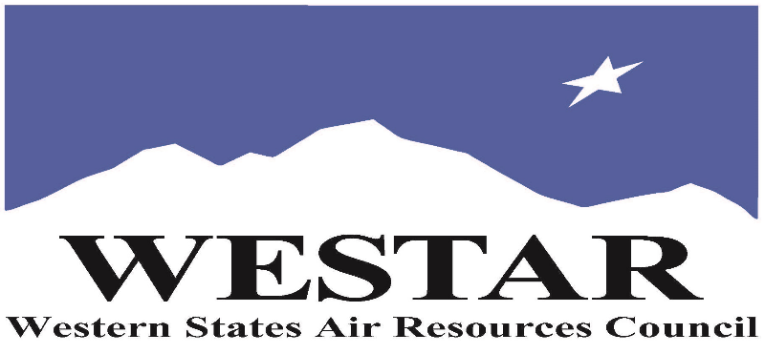

TO REGISTER
- Log onto EPA’s AirKnowledge and create a profile, or log onto your existing AirKnowledge account.
- https://epaapti.csod.com/client/epaapti/default.aspx
- When you complete your profile, you will receive a confirmation e-mail to activate your new account. It may take several minutes before receiving the email.
- Once activated, log into your account.
- Click the “Instructor Lead Training Calendar” link under the “My Training” tab.
- Search the calendar for the training date(s). On the calendar you will see a course description. Hover over the text for additional information.
- To register click the course title link.
- In the lower righthand corner of the page you will see a “Request” button. Click it.
- At this point you have requested a seat in the training. Because demand for WESTAR sponsored training frequently exceeds availability all registrants are placed on a waitlist.
- You will receive an email from Jeff Gabler confirming your request.
- WESTAR attempts to accommodate all requests but at times it may be necessary to prioritize attendees.

MONDAY, JULY 29, 2024
8:00 am Introduction, Background, Course Overview
8:30 am Background & History/Prevention of Significant Deterioration (PSD Applicability)
9:45 am Break
10:00 am PSD Applicability
11:30 am Lunch (on your own)
12:45 pm PSD Applicability (cont’d)
2:45 pm Break
3:00 pm PSD Applicability (cont'd)
4:30 pm Adjourn for Day

TUESDAY, JULY 30, 2024
8:00 am PSD Applicability (cont’d)
9:45 am Break
10:00 am PSD Requirements – Best Available Control Technology (BACT)
11:30 am Lunch (on your own)
12:45 pm PSD Requirements – Nation Ambient Air Quality Standards (NAAQS) Analysis
2:45 pm Break
3:00 pm PSD Requirements – Increment and Other Analyses
4:30 pm Adjourn

ABOUT THE TRAINING
COURSE DESCRIPTION: This basic permitting writing training course focuses on the most important air pollution permitting aspects of the Clean Air Act’s mandatory NSR/PSD and Title V permitting programs including sections on operating permit requirements, permit drafting and analysis, source monitoring, compliance and enforcement, alternative approaches, and record keeping and resources. The NSR portion of the course focuses on the treatment of key NSR components (applicability, BACT, impact analyses).

SPACE LIMITATION: Registration is limited to 30 attendees. Air quality staff from the fifteen western states receive registration preference.

REGISTRATION FEES: There are no registration fees for state, local or tribal air quality agency staff. For federal employees the registration fees are $700.

ACCESSIBILTY/MATERIALS
ACCESSIBILTY: WESTAR strives to host inclusive, accessible training events that enable all individuals, including individuals with disabilities, to engage fully with the instructor and course content. To request an accommodation or for inquiries about accessibility, please contact Jeff Gabler at jgabler@westar.org or 503-744-0486 by Friday, June 28, 2024.

COURSE MATERIALS: Training course materials will only be available electronically. Attendees will receive an online document sharing link for access to materials. It is the attendee’s responsibility for downloading files and for providing the device or media on which to view materials. WESTAR will provide hard copies for those needing accommodation.
TRAINING LOCATION

Northern Nevada Public Health
Conference Rooms A&B
1001 E. Ninth Street, Building B
Reno, Nevada 89512

HOTEL INFORMATION
Attendees and speakers are responsible for making their own hotel reservations. Below is a list of hotels within ~.50 miles of Northern Nevada Public Health. WESTAR does not have a block for guest rooms. Please ask for government rate.

Ramada by Wyndham Reno Hotel & Casino

1000 E 6th St, Reno, NV 89512

