WESTAR Council

Advanced New Source
Review (NSR)/Prevention of
Significant Deterioration (PSD)

December 17-20, 2024

IN-PERSON TRAINING

Colorado Dept. of Public Health & Environment (CDPHE)
4300 Cherry Creek Drive South (Mtg. Rm. B1F)
Denver, CO 80246

Registration Deadline: Friday, November 15, 2024

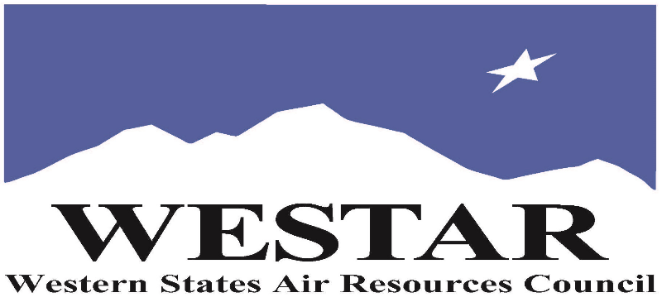

TO REGISTER
- Log onto EPA’s AirKnowledge and create a profile, or log onto your existing AirKnowledge account.
https://epaapti.csod.com/client/epaapti/default.aspx
- When you complete your profile, you will receive a confirmation e-mail to activate your new account. It may take several minutes before receiving the email.
- Once activated, log into your account.
- Click the “Instructor Lead Training Calendar” link under the “My Training” tab.
- Search the calendar for the training date(s). On the calendar you will see a course description. Hover over the text for additional information.
- To register click the course title link.
- In the lower righthand corner of the page you will see a “Request” button. Click it.
- At this point you have REQUESTED a seat in the training. Because demand for WESTAR sponsored training frequently exceeds availability all registrants are placed on a waitlist.
- You will receive an email from Jeff Gabler confirming your request.
- WESTAR attempts to accommodate all requests but at times it may be necessary to prioritize attendees.

TUESDAY, DECEMBER 17, 2024
8:30 am Welcomes & Introductions
8:45 am Background and General Overview
9:45 am Brak
10:00 am General Overview and Administrative Law
11:30 am Lunch (on your own)
12:45 pm Definitions (Emission Unit/Stationary Source)
2:30 pm Break
2:45 pm Definitions (Stationary Source/Major Stationary Source)
4:30 pm Adjourn for Day

WEDNESDAY, DECEMBER 18, 2024
8:30 am Definitions (Fugitive Emissions/Regulated NSR Pollutant)
9:30 am Break
9:45 am Definitions (Potential to Emit (PTE)/Secondary
Emissions/Construction/Significant)
11:30 am Lunch (on your own)
12:45 pm Definitions (Modifications/Major & Minor Modifications)
2:30 pm Break
2:45 pm Definitions (Major Modifications/RMRR and Other
Exclusions
4:30 pm Adjourn for Day

THURSDAY, DECEMBER 19, 2024
8:30 am Definitions (Replacement Units/Project Aggregation/
Projected Actual Emissions), and Applicability Analyses
9:30 am Break
9:45 am Applicability Analyses and Other Applicability Topics
11:30 am Lunch (on your own)
12:45 pm Applicability, Court Cases, Other Topics
2:30 pm Break
2:45 pm Synthetic Minor Limits and Definition (Net Emission
Increase)
4:30 PM Adjourn for Day
FRIDAY, DECEMBER 20, 2024
8:30 am Source Obligation & PSD Program (BACT)
9:30 am Break
9:45 am PSD Program (Ambient Air Quality Analysis/Air Quality
Impact Analysis)
11:30 am Lunch (on your own)
12:45 pm Nonattainment Area Program
(Applicability/LAER/Offsets)/PSD Program (PALs, Class I
Impacts
2:30 pm Break
2:45 pm Compliance/Enforcement & Other Topics
4:00 pm Q&A Session
4:30 PM Adjourn for Day

COURSE DESCRIPTION
WESTAR’s Training Program will host this 4-day Advanced NSR/PSD training course for EXPERIENCED agency personnel who have permitting responsibilities for major sources. The goals of the course are to provide an in-depth, high-level understanding of permitting elements, regulatory requirements, and policies pertaining to the major New Source Review program. The training will provide attendees with the knowledge, skills, and abilities to identify pertinent regulatory and policy materials, and the ability to apply these to day-to-day responsibilities and activities. It will cover case law that is important to the NSR program and tools to enable attendees to identify pertinent regulatory and policy materials.

THIS COURSE IS FOR EXPERIENCE PERMITTING STAFF WHO HAVE ATTENDED WESTAR’S INTERMEDIATE NSR/PSD TRAINING COURSE.

ACCESSIBILTY/MATERIALS
ACCESSIBILTY: WESTAR strives to host inclusive, accessible training events that enable all individuals, including individuals with disabilities, to engage fully with the instructor and course content. To request an accommodation or for inquiries about accessibility, please contact Jeff Gabler at jgabler@westar.org or 503-744-0486 by Friday, November 15, 2024.

COURSE MATERIALS: Training course materials will only be available electronically. Attendees will receive an online document sharing link for access to materials. It is the attendee’s responsibility for downloading files and for providing the device or media on which to view materials. WESTAR will provide hard copies for those needing accommodation.
SPACE LIMITATION: Registration is limited to 40 attendees. Air quality staff from the fifteen western states receive registration preference.
REGISTRATION FEES: There are no registration fees for state, local or tribal air quality agency staff. For federal employees the registration fees are $2,500.
TRAINING LOCATION

Colorado Dept. of Public Health & Environment (CDPHE)
4300 Cherry Creek Drive South (Mtg. Rm. B1F)
Denver, CO 80246

HOTEL INFORMATION
Attendees and speakers are responsible for making their hotel reservations. Below is a list of potential hotels in the Cherry Creek area. WESTAR DOES NOT have room blocks at these hotels. Please ask for government rates.

Hilton Garden Inn Cherry Creek
600 S Colorado Blvd
Denver, CO 80246
Tel: 303-754-9800

Hampton Inn and Suites Cherry Creek
4150 E. Kentucky Ave
Glendale, CO 80246
Tel: 303-692-1800

Marriott Residence Inn Cherry Creek
670 S. Colorado Blvd
Denver, CO 80246
Tel: 303-758-6200

