WESTAR Council

Advanced Inspector
Training (NACT355)

July 16-18, 2024

IN-PERSON TRAINING

State of Utah
Multi-Agency State Office Building
195 N 1950 W
4th Floor – 4 Corners Rm
Salt Lake City, UT 84116

REGISTRATION DEADLINE:
Friday, June 14, 2024

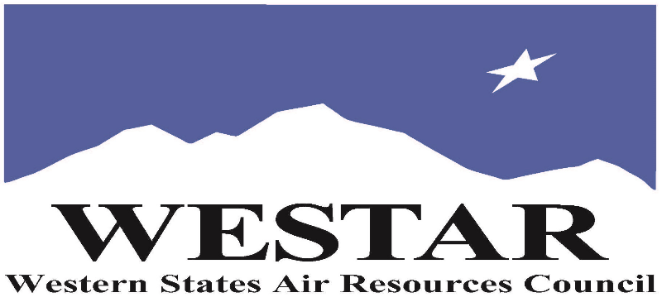

TO REGISTER
- Log onto EPA’s AirKnowledge and create a profile, or log onto your existing AirKnowledge account.
- https://epaapti.csod.com/client/epaapti/default.aspx
- When you complete your profile, you will receive a confirmation e-mail to activate your new account. It may take several minutes before receiving the email.
- Once activated, log into your account.
- Click the “Instructor Lead Training Calendar” link under the “My Training” tab.
- Search the calendar for the training date(s). On the calendar you will see a course description. Hover over the text for additional information.
- To register click the course title link.
- In the lower righthand corner of the page you will see a “Request” button. Click it.
- At this point you have requested a seat in the training. Because demand for WESTAR sponsored training frequently exceeds availability all registrants are placed on a waitlist.
- You will receive an email from Jeff Gabler confirming your request.
- WESTAR attempts to accommodate all requests but at times it may be necessary to prioritize attendees.

TUESDAY, JULY 16, 2024
8:30 am Introduction, Background, Course Overview & Pre-Test
9:45 am Inspector Issues (Entry, National Initiatives, CMS,…)
10:45 am Break
11:00 am Digital World
11:45 am Introduction to Practical Exercise/Break into Groups
12:00 noon Lunch (on your own)
1:15 pm Practical Exercise
- Conduct Two Interviews
- Sampling
- Writing Inspection Report
4:30 pm Adjourn for the Day

WEDNESDAY JULY 17, 2024
8:30 am Writing Inspection Report (cont’d)
10:15 am Break
10:30 am Review Group Reports, Interviews and Sampling
12:00 noon Lunch (on your own)
1:15 pm Note Taking and Report Writing
2:30 pm Break
2:45 pm Interviewing Practical Exercise
3:00 pm Interviewing Skills
4:00 pm Alternative Compliance Monitoring Methods
4:30 pm Inspector Issues
4:30 pm Adjourn for the Day

THURSDAY, JULY 18, 2024
8:30 am How to be an Effective Witness
9:15 am Field Technology (IR) and DOC
10:15 am Description of Criminal Program
11:00 am Review Questions, Wrap-Up, and Post-Test
11:30 pm Adjourn

ABOUT THE TRAINING
COURSE DESCRIPTION: The Advanced Inspector Training Course focuses on issues and techniques for the more senior inspector to help enhance and improve their inspection techniques and results. This course does not focus on any specific media but covers subject applicable to inspections in all media. The course is intended to provide additional tools to obtain information before, during, and after an inspection. The course will present “best practices” for conducting inspections and give the students an opportunity to discuss how these “best practices” apply or not to their own inspections. Each class will have the opportunity to discuss and evaluate specific issues or areas of interest to them.
SPACE LIMITATION: Registration is limited to 30 attendees. Air quality staff from the fifteen western states receive registration preference.
REGISTRATION FEES: There are no registration fees for state, local or tribal air quality agency staff. For federal employees the registration fees are $100.

ACCESSIBILTY/MATERIALS
ACCESSIBILTY: WESTAR strives to host inclusive, accessible training events that enable all individuals, including individuals with disabilities, to engage fully with the instructor and course content. To request an accommodation or for inquiries about accessibility, please contact Jeff Gabler at jgabler@westar.org or 503-744-0486 by Friday, June 14, 2024.

COURSE MATERIALS: Training course materials will only be available electronically. Attendees will receive an online document sharing link for access to materials. It is the attendee’s responsibility for downloading files and for providing the device or media on which to view materials. WESTAR will provide hard copies for those needing accommodation.
TRAINING LOCATION

State of Utah
Multi-Agency State Office Building
195 N 1950 W
4th Floor – 4 Corners Rm
Salt Lake City, UT 84116

HOTEL INFORMATION
Attendees and speakers are responsible for making their own hotel reservations. Below is a list of hotels within ~.50 miles of the State of Utah. WESTAR does not have a block for guest rooms. Please ask for government rate.

Radisson Hotel Salt Lake City Airport

2177 W. North Temple, Salt Lake City, UT 84116

Sonesta Simply Suites Salt Lake City Airport

2170 W North Temple, Salt Lake City, UT 84116

Comfort Suites

171 N 2100 W, Salt Lake City, UT 84116

Holiday Inn Express Hotel & Suites

200 N 2100 W, Salt Lake City, UT 84116

