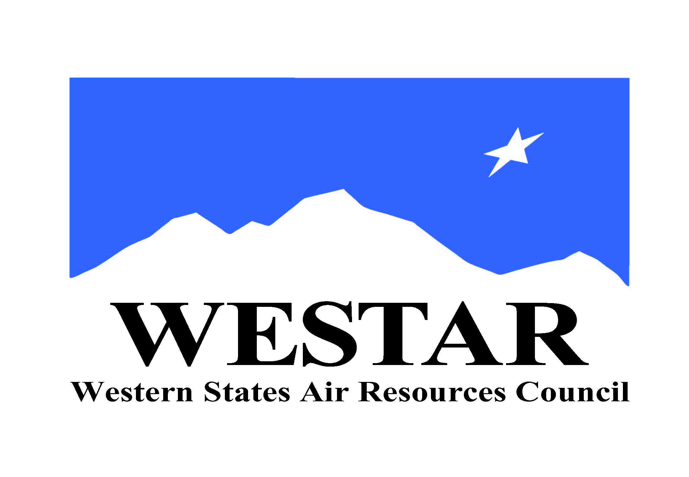
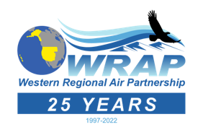

WRAP Work Topic Areas – changes/updates of Nov. 14, 2022

WRAP Topic Areas – Future Projects/Tasks, and Background Information (December 1, 2020) – Board approval December 2, 2020

Topic / WRAP “home” | Dec. 2020 Board-approved Project/Task (renumbered into each WRAP “home”, propose to remove some elements shown as strikethrough) | November 2022 progress update
Fire and Smoke Emissions and Impacts  /  Fire & Smoke WG | - Identify all the smoke management plans (SMPs) in the region and compare them (e.g. decision making process, rules, activity, seasonality)  - Create a site for tracking regional burn decisions in near real-time that lists info on decisions and completed burns from fire agencies  - Research and develop data needs and sources, emission inventory approaches, and evaluate remote sensing products  - Wildfire data (monitoring, modeling, emissions, etc.)  - Coordinate on wildland prescribed fire and smoke management programs | - FSWG workplan scope Board approved 3/3/21  - Plan for monthly calls  - Focuses on smoke emissions and modeling, smoke management planning and coordination, and exceptional events support  - Exceptional Events team calls underway addressing tasks in workplan scope  - Implementation of Conceptual Model for Fire Data project findings will require dedicated ongoing funding. Stakeholder workshop held.  - Joint calls with National Wildfire Coordinating Group (NWCG) Smoke Managers Subcommittee underway  - Fire and Smoke Air Quality Collaborative meeting planned 11/16-17/22  - FSWG membership list TSC approved 9/28/22
Oil & Gas Emissions Tracking and Analysis  /  Oil & Gas WG | - Extend period of performance for Ramboll contract to allow for items such as state specific assistance  - Annual compilation of agency program review to capture regulatory changes  - Assess and improve 2017 NEI O&G emissions estimates for IWDW-WAQS western regional modeling | - OGWG workplan scope Board approved 12/9/21  - Plan for Tri-Annual Work Group calls  - Plan for additional focused workplan scope implementation meetings  - Conduct annual survey of Oil and Gas-related air quality management needs  - Improve emissions inventories for the region and individual jurisdictions  - Prepare annual assessment to track efforts to implement rules and control strategies, and report on compliance activities and emissions management structures  - Resources not available at this point in time for contractor support to accomplish items 1 and 3  - OGWG membership list TSC approved 9/28/22
Regional emissions and air quality analysis  /  Regional Technical Operations WG | - Conduct an ozone source apportionment modeling run using CAMx APCA (Anthropogenic Precursor Culpability Assessment) diagnostic tool to apportion source categories and states contributing to regional ozone transport and international contributions  - Build and evaluate base year model performance for 2017 IWDW-WAQS western regional modeling platform  - Identify Emission Inventory development needs and refinements, both anthropogenic and natural (such as Biogenic Emissions Inventory Improvements) | - RTOWG workplan scope Board approved 12/9/21  - Plan for quarterly calls  - Modeling and analyses to investigate air quality topics of interest in the western US, including visibility, ozone, and nitrogen deposition, and to identify emission sources that are contributing to regional air pollution  - Resources not available at this point for contractor support to accomplish item 1  - Work on Item 2 complete, limited to 2017 meteorological and model boundary conditions modeling, end of 2017 modeling work  - No funding source identified for a more current year modeling platform development through IWDW-WAQS. Substantial funding for IWDW-WAQS funded contractor support not anticipated until 2023  - RTOWG membership list TSC approved 9/28/22
Regional Haze SIP Completion and Implementation  /  Regional Haze Planning Work Group | - Ongoing Regional Haze planning support from WESTAR-WRAP staff | - RHPWG workplan scope Board approved 12/9/21  - Plan for quarterly calls  - Prepare and implement the framework to support regional planning for the 15-state WRAP region  - Assure RHR required SIP elements are available for use in WRAP region  - Rhonda Payne and Jay Baker to help with item 1  - RHPWG membership list TSC approved 9/28/22
WRAP Tribal Member Support  /  Tribal Data Work Group | - Technical assistance for tribes with state SIP (or related) reviews | - TDWG workplan scope Board approved 4/7/22  - Plan for quarterly calls  - Provide needed information and services to the WRAP membership (not limited to the 28 active voting WRAP member tribes) as per the Topical Areas listed for the workplan scope  - Limited ITEP resources available for any tribe needing help with item 1 (first-come, first-served)  - TDWG membership list TSC approved 9/28/22
WESTAR/WRAP-wide studies  /  WRAP staff | - Apply remote sensing data for air quality forecasting, for air quality management, and to public health decisions  - Implement projects proposed to NASA when/if funded  - Applying Advanced Earth Science Data for Aiding Air Quality Forecasting and Management Decisions  - Applying Earth Science Data to Air Quality Management and Public Health Decisions  3) Assess regional resources to support emerging topics and needs  - Small sensors / alternative monitoring technologies  - Air toxics monitoring  - Fenceline monitoring  - Environmental justice initiatives  - GHG/other inventories | - No NASA funded projects for item 2  - No progress yet on items 1 or 3a-e

