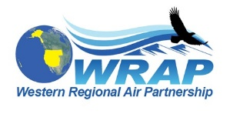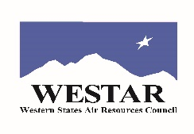

working version – summary program agenda for April 5, 2022
WRAP 25th Anniversary Celebration - Park City, UT
(January 18, 2022)
All names listed are to be invited and are not confirmed at this time
Lightning round names are in order of preference for trying to get

Assume Day 1 of WESTAR-WRAP meeting ends ~5 pm

Start celebration at 6 pm, to be 3ish hours in length
  - Have food and drink ready to go, to serve as dinner and transition to celebrating
  - Food to be appetizers/hors d’oeuvres, beverages to be cash bar, WESTAR provide non-alcoholic drinks
  - Provide in-person and virtual access, designate photographer to take pictures for posting

- Welcome and opening remarks (30 mins.)
  - WRAP Board State and Tribal Co-Chairs (Alice Edwards, Mary Uhl, Gordon Pierce, Randy Ashley - hear from both present and past in attendance)
  - Play recorded remarks by former Gov. Leavitt (or in person) and/or a Tribal leader
  - Overview of celebration events

- Entertainment 1 (25 mins.)
  - Audio/Video/PPT feature with songs/skits
  - WESTAR-WRAP region Class I areas’ slide show

- Lightning round remarks / testimonials A (5-7 mins. each, 20 mins. total) - selected WRAP history topics (pre-recorded)

- WRAP formation (GCVTC in background) - John Leary, Ursula’s remarks, Bill Auberle, Mike George
- Regional Haze program, SIP development, planning effort - Bruce Polkowsky, Dave McNeill, Brian Finneran, Tina Anderson, Tina Suarez-Murias
- Achievements as a membership organization / hindsight on topics - Pat Cummins, CV Mathai, Reuben Plantico, Vickie Patton, Cathy Van Dame, Tom Webb, John Vimont, Tom Moore

Social break (20ish mins.)

- Lightning round remarks / testimonials B – key thematic topics + future (5-7 mins. each, 30 mins. total, pre-recorded)

- Stationary Sources, backstop trading program concept, trend of declining fossil power production and alternative energy sources - Colleen Delaney, Ira Domsky
- Fire and Smoke, what’s learned, what’s in front of us - Pete Lahm, Mark Fitch, Darla Potter
- Federal Agencies as partners - Tim Allen, John Vimont, Colleen McKaughan
- Development of capacity and involvement of Tribes, example of Tribal Resources - Jason Walker, Randy Ashley, Mel Joseph, Lori Howell, Bill Grantham?
- Future of WRAP, the members, the region – Mary, Gordon, Randy

- Open microphone for anyone in attendance - emcee to limit individual storytelling to be up to 2 mins. each (total 30 mins, initial list)
- Amber Potts
- David Stroh
- Rhonda Payne
- Jeffrey Stocum
- Emma Ruppell
- Chelsea Cancino
- Ryan Templeton
- Elias Toon
- Rebekka Fine
- Kirsten King
- Linda Geiser
- Frank Forsgren
- Tina Suarez-Murias
- Lee Gribovicz

- Entertainment 2 (20 mins.) – Mary Uhl and Mike Morris (special prizes)
- WRAP Jeopardy
- “guess that Class I area”

- WRAP-up - Gordon and Randy
  - Thanks to all, remembrances
  - Rest of attendees pick up commemorative mugs
  - See you tomorrow for breakfast before the WESTAR-WRAP meeting

WRAP 25th Anniversary celebration momentos
  - Mugs - insulated tumblers, WRAP logo with 25 years on one side
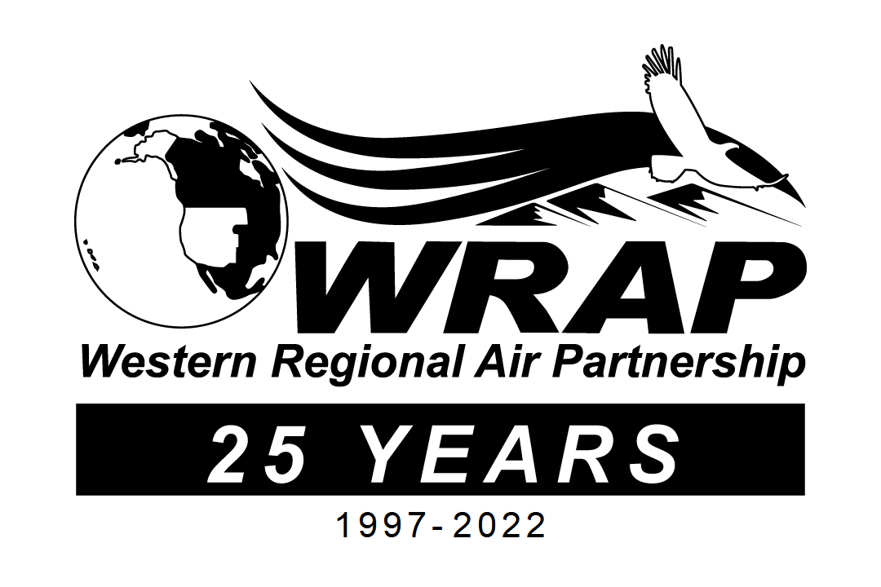

- Page on new WESTAR-WRAP website
  - photos, highlights, anniversary celebration info
  - summary history of WRAP formation – why, when, whom, how + expansion over time

