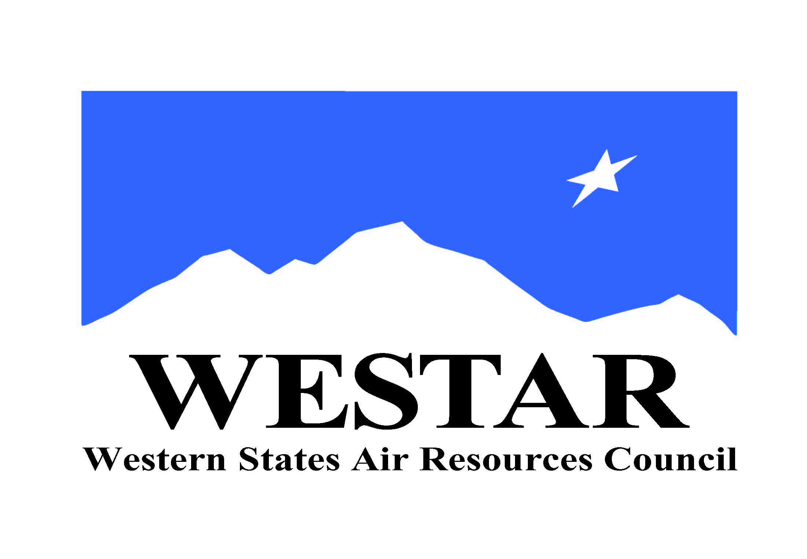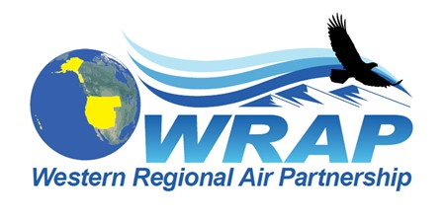
WRAP Work Topic Areas – Board approval December 2, 2020 – changes/updates of Sept. 24, 2021

Topic / WRAP “home” | Dec. 2020 Board-approved Project/Task (renumbered into each WRAP “home”, propose to remove some elements shown as strikethrough) | Sept. 2021 update
Fire and Smoke Emissions and Impacts  /  Fire & Smoke WG | - Identify all the smoke management plans (SMPs) in the region and compare them (e.g. decision making process, rules, activity, seasonality)  - Create a site for tracking regional burn decisions in near real-time that lists info on decisions and completed burns from fire agencies  - Research and develop data needs and sources, emission inventory approaches, and evaluate remote sensing products  - Wildfire data (monitoring, modeling, emissions, etc.)  - Coordinate on wildland prescribed fire and smoke management programs | - FSWG Workplan Scope adopted January 26, 2021 – defines mission statement, membership, and goals  - Regular meetings underway  - 5 Subcommittee Teams identified, addressing projects/tasks in workplan scope  - Exceptional Events team underway  - Implementation of Conceptual Model for Fire Data project findings will require dedicated ongoing funding, NASA funding proposal submitted June 30, 2021
Oil & Gas Emissions Tracking and Analysis  /  Oil & Gas WG | - Extend period of performance for Ramboll contract to allow for items such as state specific assistance  - Annual compilation of agency program review to capture regulatory changes  - Assess and improve 2017 NEI O&G emissions estimates for IWDW-WAQS western regional modeling | - OGWG workplan scope drafted and under review  - Resources not available at this point in time for contractor support to accomplish items 1 and 3  - Based on survey and discussion efforts with OGWG members, draft workplan scope identifies efforts by OGWG member agencies to collaboratively work on topics listed in scope
Regional emissions and air quality analysis  /  Regional Technical Operations WG | - Conduct an ozone source apportionment modeling run using CAMx APCA (Anthropogenic Precursor Culpability Assessment) diagnostic tool to apportion source categories and states contributing to regional ozone transport and international contributions  - Build and evaluate base year model performance for 2017 IWDW-WAQS western regional modeling platform  - Identify Emission Inventory development needs and refinements, both anthropogenic and natural (such as Biogenic Emissions Inventory Improvements) | - RTOWG workplan scope to be drafted in Oct.  - Resources not available at this point for contractor support to accomplish item 1  - Work on Item 2 complete, limited to 2017 meteorological and model boundary conditions modeling, end of 2017 modeling work  - Draft workplan scope to identify efforts by member agencies and plans for a more current year (2020/2021) modeling platform development through IWDW-WAQS  - Substantial funding for IWDW-WAQS funded contractor support not available until 2023
Regional Haze SIP Completion and Implementation  /  Regional Haze Planning Work Group | - Ongoing Regional Haze planning support from WESTAR-WRAP staff | - Tom Moore and Jay Baker to help with #1  - No definitive plan yet for updated Workplan Scope from RHPWG
WRAP Tribal Member Support  /  Tribal Data Work Group | - Technical assistance for tribes with state SIP (or related) reviews | - Limited ITEP resources available for any tribe needing help with #1 (first-come, first-served)  - No definitive plan yet for updated Workplan Scope from TDWG
WESTAR/WRAP-wide studies  /  WRAP staff | - Apply remote sensing data for air quality forecasting, for air quality management, and to public health decisions  - Implement projects proposed to NASA when/if funded  - Applying Advanced Earth Science Data for Aiding Air Quality Forecasting and Management Decisions  - Applying Earth Science Data to Air Quality Management and Public Health Decisions  3) 2) Assess regional resources to support emerging topics and needs  - Small sensors / alternative monitoring technologies  - Air toxics monitoring  - Fenceline monitoring  - Environmental justice initiatives  - GHG/other inventories | - In June, WESTAR-WRAP submitted as the lead or was part of 3 NASA ROSES funding proposals  - Wildland Fire Emissions Data Warehouse (WFEDW, led by WESTAR-WRAP)  - Organizing Remote Sensing Science Data for a Purpose: Decision Support Systems for Air Quality Management Applications (co-led by Univ. of Alabama Huntsville and WESTAR-WRAP)  - Western Initiative for State relevant Air Research for Decision making (WISARD, led by Univ. of Washington)  - If any of these are funded, work would start in early 2022 and utilize in-kind oversight and participation by Technical Steering Committee, WRAP Work Groups, and WESTAR Planning and Technical Committees  - For #2a, WESTAR intends to start a Technical Committee subgroup.  - No progress yet on 2b-e.

