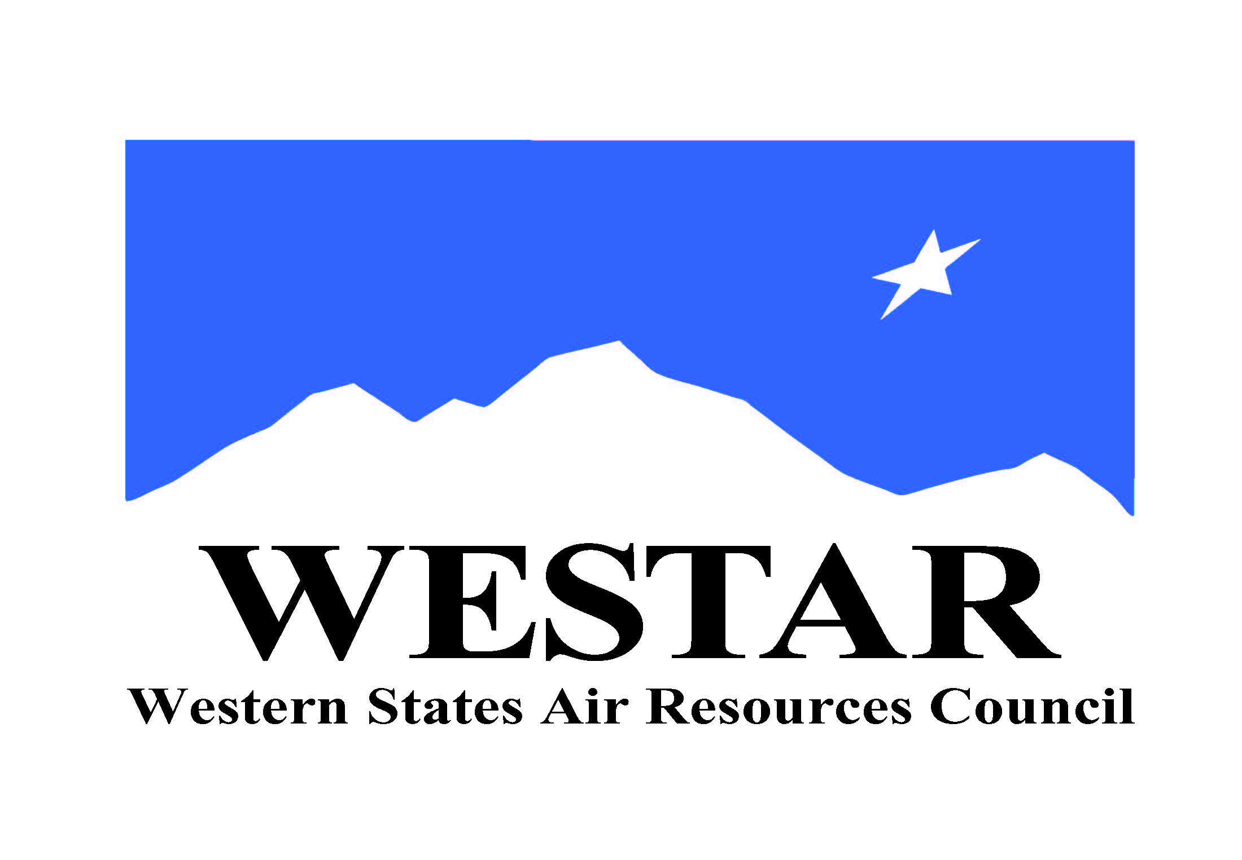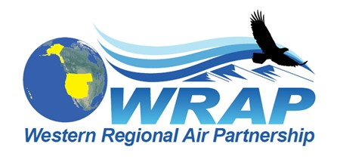
WRAP Topic Areas – Future Projects/Tasks, and Background Information (August 25, 2020)
Topic / WRAP “home” | Project/Task | Background Info | Geographic Scope | Likely Support
Fire and Smoke Emissions and Impacts  /  Fire & Smoke WG | - Identify all the smoke management plans (SMPs) in the region and compares them (e.g. decision making process, rules, activity, seasonality)  - Create a site for tracking regional burn decisions in near real-time that lists info on decisions and completed burns from fire agencies  - Research and develop emission inventory approaches and evaluate remote sensing products  - Wildfires (monitoring, modeling, emissions, etc.)  - Prescribed fire and smoke management programs | - May require further discussion of FSWG membership and goals  - Will require dedicated ongoing funding  - Other? | WESTAR-WRAP region-wide  CenSARA and LADCO regions  International data needed as well | In-Kind:  Funding:
Oil & Gas Emissions Tracking and Analysis  /  Oil & Gas WG | - Extend period of performance Ramboll contract to allow for items such as state specific assistance  - Annual compilation of agency program review to capture regulatory changes | - May require further discussion of OGWG membership and goals  - Will require dedicated ongoing funding  - Other? | CA, AK, Intermountain region-wide  CenSARA regions | In-Kind:  Funding:
Regional emissions and air quality analysis

/

Regional Technical Operations WG

