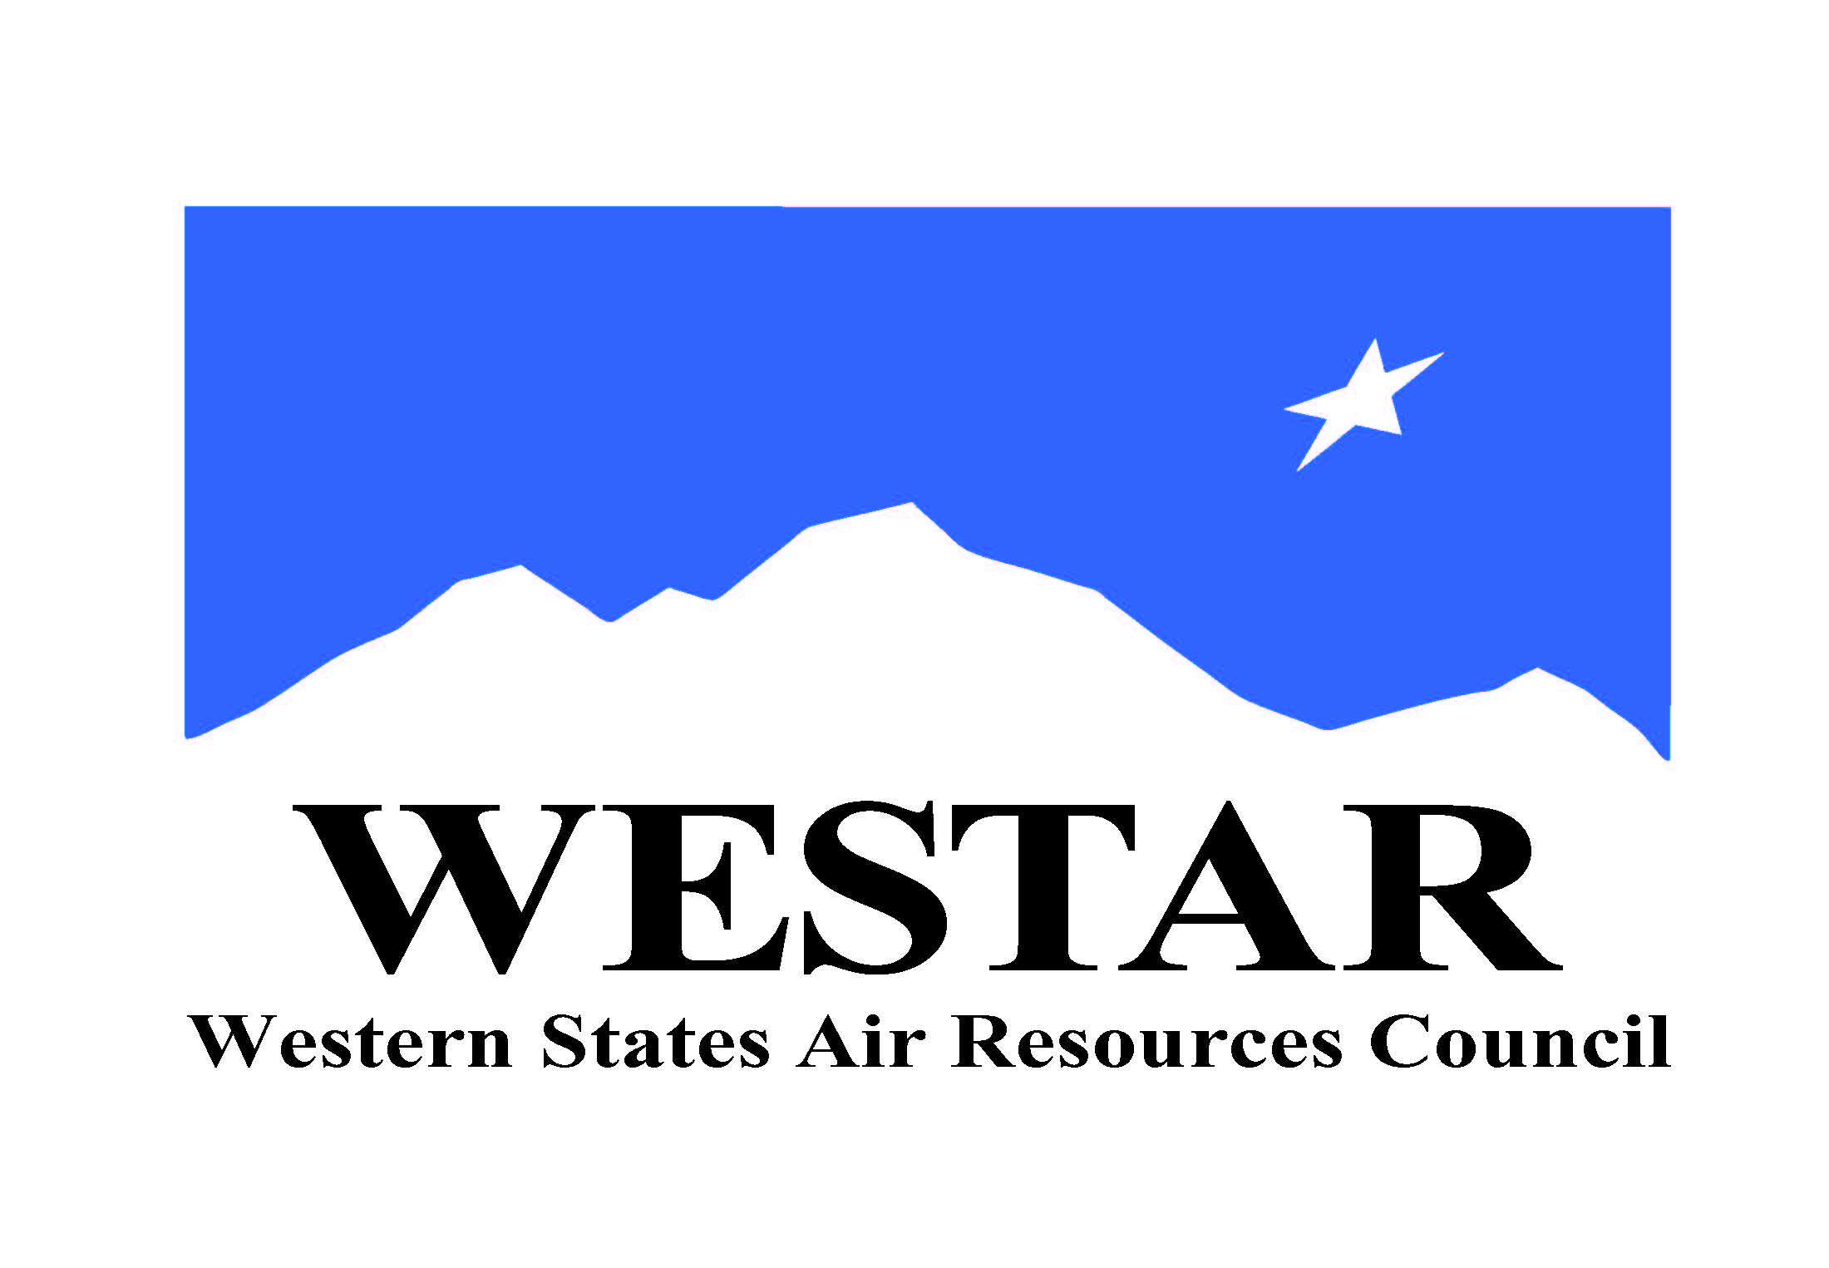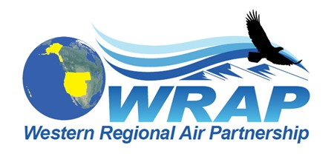
WRAP Topic Areas – Future Projects/Tasks, and Background Information (December 1, 2020)

Topic / WRAP “home” | Project/Task | Background Info | Geographic Scope | Likely Support
Fire and Smoke Emissions and Impacts  /  Fire & Smoke WG (needs an updated mission statement) | - Identify all the smoke management plans (SMPs) in the region and compare them (e.g. decision making process, rules, activity, seasonality)  - Create a site for tracking regional burn decisions in near real-time that lists info on decisions and completed burns from fire agencies  - Research and develop data needs and sources, emission inventory approaches, and evaluate remote sensing products  - Wildfire data (monitoring, modeling, emissions, etc.)  - Coordinate on wildland prescribed fire and smoke management programs | - Requires update to FSWG mission statement, membership, and goals  - Implementation of Conceptual Model for Fire Data project findings will require dedicated ongoing funding  - Other? | WESTAR-WRAP region-wide  Include CenSARA and LADCO regions as well?  International data needed as well | In-Kind: state, tribe, federal land manager participation in FSWG and associated project  Funding: WESTAR to fund Conceptual Model for Fire Data project
Oil & Gas Emissions Tracking and Analysis  /  Oil & Gas WG | - Extend period of performance for Ramboll contract to allow for items such as state specific assistance  - Annual compilation of agency program review to capture regulatory changes  - Assess and improve 2017 NEI O&G emissions estimates for IWDW-WAQS western regional modeling | - Contractor task work supported by in-kind oversight by OGWG  - Will require regular discussion and oversight by OGWG  - Other? | CA, AK, Intermountain region-wide  CenSARA region | In-Kind: state, tribe, federal land manager participation in OGWG  Funding: WESTAR to fund limited-scope contractor support for task work
Regional emissions and air quality analysis  /  Regional Technical Operations WG | - Conduct an ozone source apportionment modeling run using CAMx APCA (Anthropogenic Precursor Culpability Assessment) diagnostic tool to apportion source categories and states contributing to regional ozone transport and international contributions  - Build and evaluate base year model performance for 2017 IWDW-WAQS western regional modeling platform  - Identify Emission Inventory development needs and refinements, both anthropogenic and natural (such as Biogenic Emissions Inventory Improvements) | - Contractor task work supported by in-kind oversight by RTOWG  - Will require regular discussion and oversight by RTOWG  - Other? | WESTAR-WRAP region-wide  Include CenSARA and LADCO regions as well?  International data needed as well | In-Kind: state, tribe, federal land manager participation in RTOWG  Funding: WESTAR to fund limited-scope contractor support for task work
WESTAR/WRAP-wide studies  /  WRAP staff | - Applying remote sensing data for air quality forecasting, for air quality management, and to public health decisions  - Implement projects proposed to NASA when funded  - Applying Advanced Earth Science Data for Aiding Air Quality Forecasting and Management Decisions  - Applying Earth Science Data to Air Quality Management and Public Health Decisions  - Assess regional resources to support emerging topics and needs  - Small sensors / alternative monitoring technologies  - Air toxics monitoring  - Fenceline monitoring  - Environmental justice initiatives  - GHG/other inventories | - For 12 and 13, contractor work supported by in-kind oversight by Technical Steering Committee, and WESTAR Planning and Technical Committees  - For 14, prepare assessment and decide how to implement in WESTAR-WRAP groups (Note: Small sensor workgroup planned to be formed in WESTAR Technical Committee)  - Will require regular discussion and oversight by TSC and WESTAR Committees  - Other? | WESTAR-WRAP region-wide  Include CenSARA and LADCO regions as well?  International data needed as well | In-Kind: state, tribe, federal land manager, local air agency, and EPA participation  Funding: For 12 and 13, WESTAR to fund limited-scope contractor support as NASA provides resources. For 14, project work and resource needs to be determined.
Regional Haze SIP Completion and Implementation  /  Tribal Data Work Group  also RHPWG ? | - Technical assistance for tribes with state SIP (or related) reviews  - Ongoing Regional Haze planning support from WESTAR-WRAP staff  - Other? | - Contractor work supported by in-kind oversight by TDWG (and RHPWG?)  - Will require regular discussion and oversight by TDWG (and RHPWG?)  - Other? | WESTAR-WRAP region-wide | WESTAR to fund limited-scope assistance to tribes via contracted support by ITEP

