# **-- Monthly Coordination Call Agenda and Notes**

# **Technical Steering Committee / Work Group Co-Chairs /**

# **RHPWG Subcommittee Leads**

December 19th, 2018 11:30 am – 1:00 pm Pacific

Noted by Kris Ray

Call in Number: (800) 768-2983

Access Code: 661 987 6342

Web Login: <https://cc.callinfo.com/r/1va38zvbs4clh&eom>

Call materials available on TSC webpage and WRAP calendar.

* Welcome, Roll Call, and Agenda Review (10 minutes) – Frank
  + ***Frank called roll from list of possible attendees of State, Tribal Federal and Local agencies***
  + Review and approve notes from October 31st call
    - ***Posted on 12-18-98, so will postpone approval until January***
  + Notes for this call – Kris Ray
* WRAP Workplan Revision (10 minutes) – Frank
  + Summary of Workplan Revisions
    - Remind workgroup co-chairs and subcommittee leads to provide revisions in January. Keep everyone coordinated, include in next set of progress slides
  + Workplan Revisions Schedule and Process
    - Sent files to co-chair and leads
    - Focus on appendices and timelines for revisions and improvements
    - Change can be made on excel files or changes to critical elements or Gnat chart.
    - First revision due 1-16-18
    - Will review all changes on January 30 call
    - Revisions in task 6 progress report, working with RH and shared data committees, all item will be on website to support progress reports
    - Liaisons from TSC to work with subcommittees and subgroups, reengage TSC to give ownership and tap their expertise to WG, candidates have been identified, will contact them after Holidays
    - Linear process diagram, challenge to construct because of the amount of information coming in. Imbed into progress reports
* Work Group Status Reports (informational only progress updates since SLC meeting, hold discussion) – (30 minutes) – **Work Group Co-Chairs – 5 minutes each TDWG, FSWG, OGWG, & RTOWG – 10 minutes RHPWG** - (see [Status Report Guidance](http://wrapair2.org/calendar/attachments/22426/18160/Work%20Group%20%20Subcommittee%20Status%20Report%20Guidance.docx))
  + TDWG – Emma provided update, calls for contract updates, next call tomorrow with deliverables, tasks data analysis and
    - No changes form SLC, some deliverable are completed and will provide more details next report
    - Projects are in progress for the items in the ITEP contract
  + FSWG
    - Revise 2014 fire base year inventory
    - Contractor needs 40 hours to complete revisions
    - Will discuss Utah’s smoke management plan in January
  + Oil and Gas Workgroup
    - Calls scheduled for the WG into 2019
    - Project management calls with federal state and local agencies, need tribal representative on WG
    - Results of Survey and updates to it, state by state and agency by agency approach
    - Forecast for 2018, several tasks complete or underway
  + RTOWG
    - Activities in November phone call, interaction with workgroup and modeling
    - Joint call with control measure subcommittee, 12-12-18.
    - Participated with the Data and glide path subcommittee, 12-13-18, overview of EPRI project on International contributions to RH.
    - Participated in the HAQAST haze and ozone call,
    - Overview of 2014 modeling platform development
      * Making progress to get running
      * Phase one awarded to Ramboll consultants, model ready by late January,
      * March 7 will host a Denver meeting or intermountain west cooperators, spend day looking at shake out model results. One day meeting then have shorter briefing for regional haze planners
  + RHWG
    - Subcommittee leads are working very well on their topics
    - All subcommittee have products for docket
    - Translation to SIP writing from tool development
    - WG will have monthly meetings to provide info and tools
    - New calendar prepared to keep States on track to complete the SIP process
    - Reviewed chart of progress on tasks to complete
    - Summary document for the work done by the Monitoring data and clide path status report.
    - Shared data base group – working actively and reviewed factsheet they are writing for SIP writers, and data users to understand regional haze
    - Emission inventory and modeling – coordinate with the 2014 modeling platform, completed white paper of 2014 EI from western states
    - Include visibility factor in screen, state decision on doing or not, find the biggest emitters to get reductions
    - Consultation and coordination subcommittee
      * White paper for 3 tier framework, spells out coordination between all entities.
    - Workplan revision for +RHWG, control strategy modeling run in 2020 so states can make additional emission reduction calculations.
* TSC Administrative and Informational Items – Frank, and Tom
  + **Discuss Coordination Needs Identified Above** (5 minutes) – Frank
    - Coordinate subcommittees,
    - Subcommittees documents foundational and ready for distribution
    - Move products on to docketing
  + **Action Items** (20 minutes)
    - Additions to Work Products/Deliverables Docket – Tom
      * [Workplan Implementation Guidance - Completion, Dissemination and Sharing of Work Products and Deliverables](http://www.wrapair2.org/pdf/WorkGroupGuidanceInfoDissem%20Sharing_approved%20by%20consensus31Oct2018.pdf) (October 31, 2018)
        + Guidance document at link and skeleton of docket on website, completed work products to be adopted by consensus at WG level then by the TSC then to adding to docket.
      * [Work Product / Deliverable Docket](http://www.wrapair2.org/TSC_Docket.aspx) (periodic updates)
    - Update TSC, Work Group and Subcommittee Membership and Contact Information - Tom
      * Workplan updates need to confirm participation list and membership of WGs, TSC and subcommittees, list for updated workplan. Co-chairs need to update these lists. Frank and Tom will compile for workplan update.
    - Ad hoc WRAP Website group – Tom
      * Formed at the SLC meeting, website not intuitive for use, took volunteers to suggest updated by contractor to make the updates
      * Need more people to be on this group
      * Bring suggestions to next TSC call
  + **Informational Items** (5 minutes)
    - IMPROVE data substitution – Pat
      * Report of request to look at sites for data substitution, states need to reply to say if that will work.
* Next Steps and Wrap up (10 minutes)
  + Review next steps and action items from call – Frank
    - Continue with revision of workplan efforts
    - Continue workload completion by WG
    - Review work products as part of docketing process
  + Next call – January 30th call, Wednesday 11:30 am – 1:00 pm Pacific – Tom
    - Note taker, Bob Kotchenruther
    - Agenda items?

**Call and Note Taking Schedule**



**WRAP Workplan Timeline to Support Regional Haze Progress Reporting**

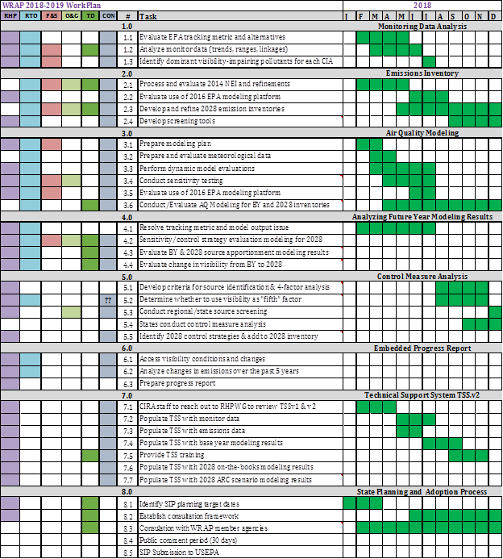

**WRAP Workplan Timeline to Support Regional Technical Analysis**

