# **-- Monthly Coordination Call Notes --**

# **Technical Steering Committee / Work Group Co-Chairs /**

# **RHPWG Subcommittee Leads**

October 31st, 2018 11:30 am – 1:00 pm PDT

Call in Number: (800) 768-2983

Access Code: 661 987 6342

Web Login: <https://cc.callinfo.com/r/1brwtgze56m14&eom>

Call materials available on TSC webpage and WRAP calendar.

* Welcome, Roll Call, and Agenda Review (10 minutes) – Julie
  + Reviewed and approved notes from August 29th and September 26th calls
  + Notes for this call – Julie Simpson, Nez Perce Tribe
  + Notes for next call (December) – Kris Ray
* Work Group Status Reports (informational only, hold discussion) – (30 minutes) – **Work Group Co-Chairs – 5 minutes each TDWG, FSWG, OGWG, & RTOWG – 10 minutes RHPWG** - (see [Status Report Guidance](http://wrapair2.org/calendar/attachments/22426/18160/Work%20Group%20%20Subcommittee%20Status%20Report%20Guidance.docx))
  + - ***TDWG: part of ITEP contract is for ITEP to assist with developing the consultation framework - ITEP will participate on the Consultation and Coordination Subcommittee.***
    - ***FSWG: three issues were identified in 2014 WRAP Fire NEI data review. (1) urban land class was confusing; (2) ag burning was not included in the version 1 NEI; (3) timing and magnitude issues with prescribed burning and the satellite detect methods EPA uses.***
    - ***OGWG: responses to the state and industry survey are important to improve the O&G inventory; will be distributed widely to regulatory agencies and sources; 2-part process will continue through January; mid-April will be Ramboll’s final base year inventory (final product related to the survey).***
    - ***RTOWG: Regional Modeling Platform RFP begin finalized. Discussed NASA HAQAST Projects and looking more closely at role of background/boundary conditions. There will end up being two model evaluations of O3 and RH using 2014 (WRAP’s evaluation) and 2016 data (EPA’s evaluation).***
    - ***RHPWG: Evaluating potential overlap, making sure there is not duplication of work among the WGs and SCs. Are working on identifying any needed revisions to deliverables schedule.*** 
      * ***Monitoring Data & Glide Path SC: Exploring ideas for natural condition estimation. Updating data evaluation tools to include 2017 datasets***
      * ***Shared Database SC: TSS v.2 Progress Report Webinar was October 5, 2018; draft glossary is available on TSS v.2 and will be updated based on feedback.***
      * ***Emissions Inventory & Modeling Protocol (EIMP) SC: Completed review on 2014 NEI v.2 and compiled revisions requested by states.***
      * ***Control Measures SC: Proposing screening tools to identify sources for further evaluation; interpreting EPA proposed guidance for 80% of non-mobile anthropogenic sources.***
      * ***Consultation & Coordination (CC) SC: Drafted timeline of informal consultation junctures during SIP development (4 key junctures, 3-tiered approach); working on draft white paper framework; need states to submit their SIP readiness surveys.***
* TSC Administrative and Informational Items – Julie, Frank, and Tom
  + **Discuss Coordination Needs Identified Above** (5 minutes) – Frank
    - ***TDWG should coordinate with CCSC on coordination/consultation protocols***
    - ***FSWG should coordinate with RTOWG on fire emissions modeling***
    - ***States need to complete the O&G survey that will be out soon***
    - ***Review the Glossary on the TSS v.2***
    - ***Coordination needed among EIMPSC, FSWG & RTOWG on baseline period averaging.***
  + **Action Items** (10 minutes)
    - [Workplan Deliverables Guidance](http://www.wrapair2.org/pdf/WorkGroupGuidanceInfoDissem%20Sharing_26Oct2018%20final%20draft.docx) – Julie
      * ***Clarifying discussion on turnaround time (about a 30-day total informational Q&A period), where will it be posted (to the Docket on the WRAP Website); importance of timeliness on work product completion (document considered final and approved-by-consensus at Work Group level; don’t want finalization of needed products getting delayed).***
      * ***Need a location for draft products for folks to work with in their SCs and WGs – Docket is for work products that have been approved as final by the WG and are ready for an informational Q&A period.***
    - Additions to Work Products/Deliverables Docket – Julie
  + **Informational Items** (25 minutes)
    - [Survey](https://www.surveymonkey.com/r/7GX8LQQ) on monthly call format and content – Julie – ***Have received 12 surveys – more on this at SLC meeting in December.***
    - Technical Planning Meeting SLC, UT Dec 4-6
      * Meeting registration and hotel reservation link: <https://western-regional-air-partnership.ticketleap.com/wrap-2018-technical-planning-meeting/>
      * Draft agenda
      * Preparing for meeting
        + Review 2018-2019 WRAP Workplan timelines and tables listing tasks/deliverables <http://www.wrapair2.org/tsc.aspx>
        + Assess work product progress and projected delivery schedule and needed Workplan revisions
      * Timeline for revision
        + Discuss final edits to Workplan revision January 30th TSC call
        + Seek approval of Workplan revisions during March Board call
        + Present Workplan revisions at April 23-24 Spring Business Meeting and discuss at April 25 WRAP Board meeting
      * ***Day 1 will be bringing everyone up to speed on progress and proposed Workplan timeline revisions; TSC will send out slide deck format within the next week***
      * ***Day 2 will focus on technical discussions, WGs and SCs will share progress on deliverables by Workplan task.***
      * ***Day 3 focus will include EPA Roadmap, review of Workplan timeline revisions, & discussion of other administrative items.***
      * ***Any other topic ideas, please submit to Frank.***
* Next Steps and Wrap up (10 minutes)
  + Review next steps and action items from call – Frank
    - ***Action items from status reports as noted above***
    - ***WGs and SCs Prepare for SLC Meeting as noted above***
  + Next call – Reschedule December 26th call, Wednesday 11:30 am – 1:00 pm Pacific – Julie
    - Note taker, Kris Ray
    - Agenda items?

**Call and Note Taking Schedule**



**WRAP Workplan Timeline to Support Regional Haze Progress Reporting**

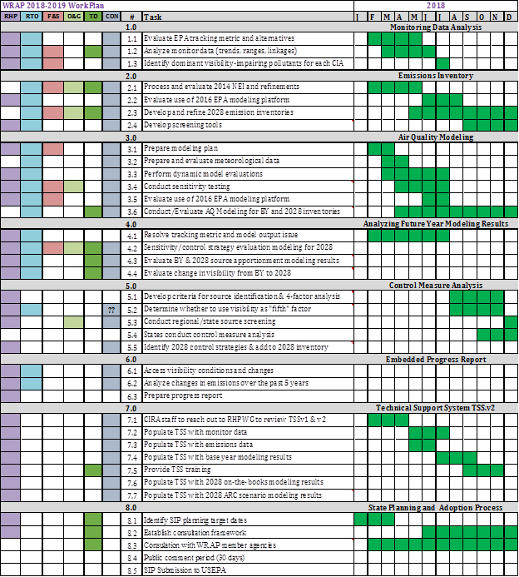

**WRAP Workplan Timeline to Support Regional Technical Analysis**

