# Technical Steering Committee/Work Group Co-Chairs Call

Call in Number: (800) 768-2983

Access Code: 661 987 6342

Web Login: [**https://cc.callinfo.com/r/1rsdg8bupdhw6&eom**](https://cc.callinfo.com/r/1rsdg8bupdhw6&eom)

## Call Agenda – August 29th, 2018 11:30 am – 1:00 pm PDT

* Welcome, Roll Call, and Agenda Review (10 minutes) – Julie
  + Review [notes from August 1st call](http://wrapair2.org/calendar/attachments/22437/18160/18.08.01%20TSC-WG%20Call%20Notes.docx)
  + Notes for this call – Phil Allen
* Work Group Status Reports (informational only, hold discussion) – (30 minutes) – **Work Group Co-Chairs – 5 minutes each TDWG, FSWG, OGWG, & RTOWG – 10 minutes RHPWG** - (see [Status Report Guidance](http://wrapair2.org/calendar/attachments/22426/18160/Work%20Group%20%20Subcommittee%20Status%20Report%20Guidance.docx) and [Status Report PPT](http://wrapair2.org/calendar/attachments/22435/18160/18.08.29%20Monthly%20Workplan%20Progress%20Update.pptx))
* TSC Administrative and Informational Items – Julie, Frank, and Tom
  + **Discuss Coordination Needs Identified Above** (5 minutes) – Frank
  + **Action Items** (10 minutes)
    - Review [state staff involvement/commitment document](http://wrapair2.org/calendar/attachments/22433/18160/Work%20Group%20and%20Subcommittee%20Staffing%20Commitments.docx%20target=) – Frank
  + **Informational Items** (25 minutes)
    - Approved by consensus [Communication/Coordination Guidance](http://wrapair2.org/calendar/attachments/22434/18160/18.08.01.Work%20Group%20Guidance.CommunicationCoordination.docx) – Frank
    - Update on Workplan Deliverables Guidance – Julie
    - [Contracting status](http://wrapair2.org/calendar/attachments/22439/18160/WRAP%20Workplan%20Contract%20Status%20report%20Aug29_2018.pdf) – Tom
      * [Planning Readiness contract](http://wrapair2.org/calendar/attachments/22442/18160/RAMBOLL%20ENVIRONMENT%20%26%20HEALTH%20-%2018-06%20WRAP%20Regional%20Haze%20Readiness%20Assessment%20project-signed_FullyExecutedAug14_2018.pdf)
      * [Regional Haze Data Analysis contract](http://wrapair2.org/calendar/attachments/22441/18160/ARS%20Regional%20Haze%20Data%20Analysis%20contract%20signed%20August%202018.pdf)
    - Master Calendar roll out– Tom
    - [Regional Modeling & Analysis platform](http://wrapair2.org/calendar/attachments/22440/18160/WRAP%20Regional%20Modeling%20and%20Analysis%20Platform%20RFP%20Status%20-%20TSC%20coord%20call%20Aug29_2018.pptx) – Tom
    - Survey on monthly call format and content – Julie
    - [December 4-6, 2018 Salt Lake City in-person WRAP Technical Planning meeting TicketLeap registration link](https://western-regional-air-partnership.ticketleap.com/wrap-2018-technical-planning-meeting/) – Frank
* Next Steps and Wrap up (10 minutes)
  + Review next steps and action items from call – Frank
  + Next call – September 26th, Wednesday 11:30 am – 1:00 pm Pacific – Julie
    - Note taker, Theresa Alexander
    - Agenda items

**Call and Note Taking Schedule**



**WRAP Workplan Timeline to Support Regional Haze Progress Reporting**

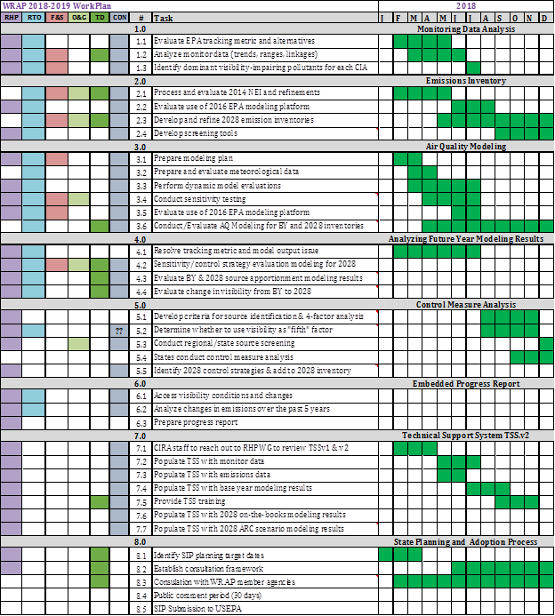

**WRAP Workplan Timeline to Support Regional Technical Analysis**

