# Technical Steering Committee/Work Group Co-Chairs Call

## June 5th, 2018 Agenda -- Call Notes by Frank Forsgren/Tom Moore

* Welcome, Roll Call, and Agenda Review (5 minutes) -- Julie and Frank

*Frank Forsgren*

*Julie Simpson*

*Kris Ray*

*Emma Ruppell*

*5 Tim Allen*

*Theresa Alexander*

*Bob Kotchenruther*

*Pat Brewer*

*Mary Uhl*

*10 Bob Lebens*

*Tina Suarez-Murias*

*Jay Baker*

*Curt Taipale*

*Cindy Hollenberg*

*15 Rebecca Harbage*

*Ryan Templeton*

*Amanda Brimmer*

*Mark Jones*

*Kevin Briggs*

*20 Mike Barna*

*John Vimont*

*Tom Moore*

* TSC Administrative and Status Report (30 minutes) – Julie, Frank, Tom, and Mary

**Action Items**

* + Call and note taking schedule – Julie (table below)

*Update schedule, dates and names for notetaking. Difficulties in viewing table prevented discussion.*

* + Request for timelines indicating state staff involvement/commitment – Frank
    - Note time line sequence and activity time periods are correct, timeframes may not be
    - Short-term versus long-term

*Reviewed. Master Gantt charts will be posted on website by TSC. Timelines will be pulled out for distribution and tracking through end of year and for 2019 by WG Co-chairs. Drafts to be discussed on June 26th call.*

* + Review/endorse Communication/Coordination memo – Frank (attached)

*Discussed, comments to Frank by June 21st, item for June 26th call.*

**Informational Items**

* + Present WRAP regional technical and coordination support memo – Mary (<https://www.wrapair2.org/pdf/Brewer%20WRAP%20support%20role_May8_2018.pdf>)

*Presented, open for review and input, evolving role, to be distributed to RHPWG list*

* + Present 2014 NEI review and projections memo – Tom (<http://views.cira.colostate.edu/wiki/wiki/9191/western-us-regional-analysis-2014-neiv2-emissions-inventory-review-for-regi>)

*Overview of 2014 NEI review wiki page, comments from state EI staff by June 14th, cycle of additional reviews during 2018*

* + Update on WRAP website additions, Master calendar development – Tom (<http://www.wrapair2.org/About.aspx>)

*Overview of “About WRAP” page and WGs/Subcommittees’ pages, master calendar to roll out in June with training*

* + Update on Technical Support System v2 - CIRA support staff on board, IMPROVE most-impaired days dataset transmitted from Ramboll to CIRA – Frank

*Overview provided, trying to make “95th percentile EPA dataset” available for Subcommittee analyses and TSS integration*

* + Update on Western Regional Haze Planning Assessment project contractor SoW – Pat

*Described, questions about timing and contracting format*

* + Modeling contract in preparation, expect Work Group review of protocol in mid-2018 – Frank

*In preparation, to be out the door in June*

* + Announcement of December 4-6, 2018 Salt Lake City in-person meeting – Frank

*Meeting to run 100 PM Dec. 4 through 1200 PM Dec. 6th, review workplan progress, TicketLeap to follow*

* Progress Reports by Work Groups (informational only, no discussion) – **5 minutes each for Work Group (TDWG, FSWG, OGWG, RTOWG, RHPWG) to present on the 3 items next – Work Group Co-Chairs**
  + Reminder of WG’s purpose and objectives
  + Identify near-term deliverables schedule and action items
  + What coordination between WGs is happening/needed?

*TDWG – Workplan detail noted, tasks discussed for bid proposal from Institute for Tribal Environmental Professionals (ITEP), coordination needed on timelines to make sure contractor support is timely, avoid duplication with other WRAP WGs.*

*Other WG reports postponed to June 26th call.*

* Discussion Item (20 minutes) – Frank, Julie, Tom, and Pat
  + Reviewing and revising visibility tracking metric for observational and model output data – goals and hurdles, developing input to contractor plan
  + Other items?

*Postponed to June 26th call*

* Next steps and action items from call
  + Coordination needs?
* Next call – June 26th, Tuesday 11:30 am – 1:00 pm Pacific

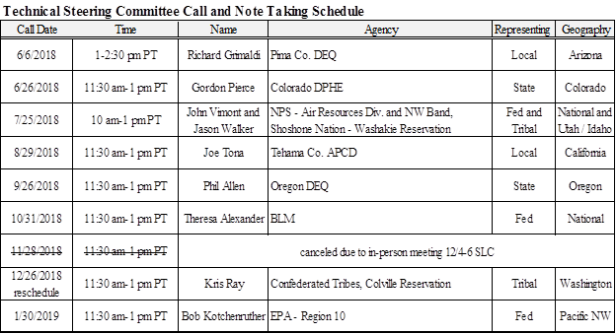

**WRAP Workplan Timeline to Support Regional Haze Progress Reporting**

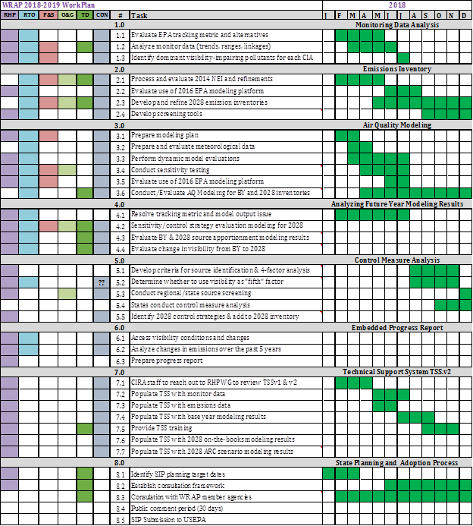

**WRAP Workplan Timeline to Support Regional Technical Analysis**

