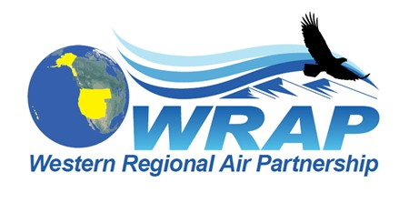

WRAP Regional Haze Workplan Completion and Results Meeting series
May 19 and 20, 2020 (April 29th draft)

This series of 3 virtual remote access meetings are to present tools and data prepared through the WRAP Workplan effort. This and subsequent meetings (#2 on June 17-18 and #3 on July 22-23) will run from 100 to about 400 PM MDT. They will be recorded.

Meeting Agenda
Call-in number and WebEx link to be added
All agenda times are Mountain Daylight Time

May 19-20 Regional Haze results #1 – virtual short format 3ish hours remote access, using the TSS - the 19th focused on monitoring and the 20th on emissions data with PAC1 modeling results.

June 17-18 Regional Haze results #2 – same 3ish hour format, using the TSS and reviewing interpretation methods for modeling results – the 17th focused on projections to 2028 and the 18th on using source apportionment/ sensitivity/WEP-AOI results

July 22-23 Regional Haze results #3 – same 3ish hours format, using case studies by states for control analysis evaluation and “checking off” the regional work product deliverables for states to use/reference in Regional Haze SIPs.

This would be the end of regional analysis except for PAC2 results in August and any subsequent modeling to be completed in 2021.

